RCPR & RSI

Dickson&hishea9frd

Ng Ying Tsan, Chung Cheuk Lam, Kwan Chung Chi

# Background

With the hype of the stock market and endorsement from big technology leaders, Cryptocurrency (Crypto) are significantly more recognizable to the public in the past few years. From pages of academic papers to a well-known investment product with trillions of values, Crypto has become a reliable tool for investors with more and more publics know its mechanism, how it works and why does is valuable. On the other hand, algorithm trading is also in the rapid race of development. A lot of investment entities have already relied on programs as their major tool for daily trading purpose. There is a myth that combining these two “high-tech” together will make stunning effects to the traditional stock market. These two components have properties that matches each other, making them great potential of combining.

Though Crypto have already survived in the market for several years, they still consider as a high-risk investment due to their high rate of fluctuation. A real time monitoring on price change is necessary to reduce risk from Crypto trading. However, as the Crypto market never close, a thorough analysis on Crypto market is nearly impossible for the human side. Algo trading plays a crucial role in this situation. With the help of cloud computing, a 7 x 24 non-stop operation of Algo is possible to achieve, which leads to a well-designed risk management on Crypto market. On top of that, Algo also provide the possibility to do short term frequency trading, which have the potential harvest more income from the market. Our proposed model, Reverse Candlestick Pattern & Relative Strength Index (RCPR & RSI), targets the advantages of frequency trading and aim to earn every single profit from every price wave.

# Component

## Candlestick analysis

Most of the technical analysis involves candlestick as the base of their model. A candlestick mainly consists of 4 variables: Open price, Close price, Highest price, Lowest price. Each candlestick represents the above 4 variables in a determined interval of time (e.g. 1min, 1hr). In our model, as we aim to do frequency trading, we will set our interval to be 30 minutes.

(Figure 1: Demonstration of a candlestick)

## Reversal Candlestick Pattern

To recognize whether there is a price fluctuation, we need to have a method to predict and send a reversal signal. By recognizing useful Candlestick Pattern (CP), we can achieve this goal. The definition of CP is the order of different shape of candlestick list in a specific order. Through the research by analysis in the past few decades, there are multiple CPs that are identify as high chance of reversal of the current price trend when it appears. These CPs are called Reversal Candlestick Pattern (RCP). In our model, we implement 10 RCPs for recognition, 5 represent a reversal to Bullish market & 5 represent a reversal to Bearish market. Recognition function for the above patterns are coded in our candlestick.py script.

Detail formula of each pattern are listed in the Appendix.

## Parabolic Stop-And-Reverse

As discussed in the previous paragraph, our model mainly uses RCPs to identify reversal of price trend. However, there is one prerequisite before doing RCPR. We need to know the current price trend of the market before RCPR as a Bullish/Bearish RCPs requires a down/up trends. In order to recognize the previous trend, we implement another index call Parabolic Stop-And-Reverse (PSAR).

PSAR is an indicator to predict trend reversal. Basically, it creates 2 types of line in analysis. One is under the price curve which indicates that the price is in a uptrend. Another one is above the price curve which indicates the prices is in a down trend. Only one type of line exists during a specific interval of the stock market. Two type of line will switch whenever the price touch the line, e.g. if the price curve touch the bottom line, the bottom line will be replaced by the ceiling line and the indicated trend changes from uptrend to down trend.

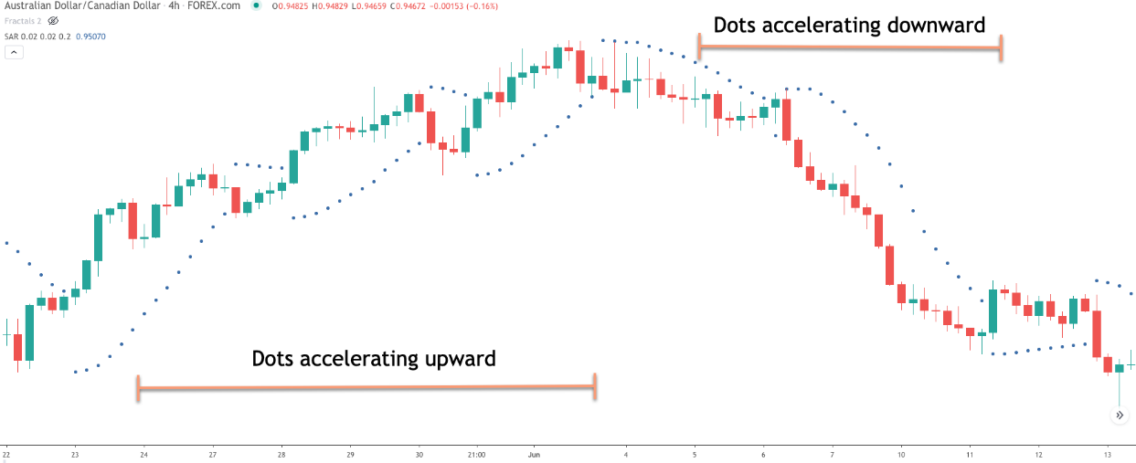

(Figure 2: illustrating PSAR ([Parabolic Stop and Reverse (Parabolic SAR) Indicator Explained - Forex Training Group](https://forextraininggroup.com/parabolic-stop-and-reverse-parabolic-sar-indicator-explained/)))

Below are the details of how to calculate the required two lines ().

(Figure 3: Formula of PSAR)

Note that in our model, we do not use PSAR as an indicator for buy / sell. PSAR solely use to recognize trend for our RCPR. The reason is to prevent too many indicators impact each other during trading. By default, our model start with a down trend PSAR.

## Relative Strength Index

Previously, our RCPR captures reversal signal and illustrates buy or sell order. However, RCPR is not comprehensive enough as it does not capture a sudden increase in an uptrend or a sudden drop in a downtrend. To fill the loophole, we implement Relative Strength Index (RSI) as an addition to supplement our RCPR.

RSI is an indicator to demonstrate the current and historical strength or weakness of a market based on the closing price of a recent trading period. It will result in a number between 0 to 100 where the number is higher, the relative strength is stronger. Usually, RSI is bound to 70 and 30, which means RSI that over 70 is strong and below 30 is weak. As we are doing short term trading, we minimize the bound window to 65 and 35 to create a shorter outlook.

Details of how to calculate RSI is shown below ():

(Figure 4: value of U and D in upward change)

(Figure 5: value of U and D in downward change)

(Figure 6: RSI formula)

SMA(X, n) indicates the simple moving average of X in period n

In our model, n is set to 14. Also since our interval is 30min, the SMA will cover 14*30min = 6h of intervals.

## Bollinger Band

# Reference

[How to Trade With Parabolic Stop and Reverse (thebalance.com)](https://www.thebalance.com/parabolic-sar-trading-1031198)

**Short-Term Stock Market**

**Prediction Based on Candlestick**

**Pattern Analysis**

[Learn what are Bollinger Bands and how to use the Bollinger Bands strategy (iforex.in)](https://www.iforex.in/education-center/bollinger-bands)